Toyota Celica TA22
(NSW RTA requirements as at 13/6/03 – May Not apply elsewhere)

Stock Tyres – 165 SR 13” (As per TA22 Celica Owners Manual – Scan Pictured below)

13” x 25.4mm = 330.2mm
165 x 82% = 135.3

330.2 + 135.3 + 135.3 = 600.8mm OD (601mm)

According to the RTA Vehicle Standards Information Sheet No. 9 “Guidelines for alternative wheels and tyres” The outside diameter of the wheel and tyre combination must be no more than 15mm over the largest diameter wheel and tyre combination specified for the vehicle and not more than 15mm below the smallest diameter wheel and tyre combination specified for the vehicle.

Therefore
Minimum OD is: 585.8 (586mm)
Maximum OD is: 615.8 (616mm)

Tyre Options. (May not list all legal options and not all sizes listed may be available)

13”
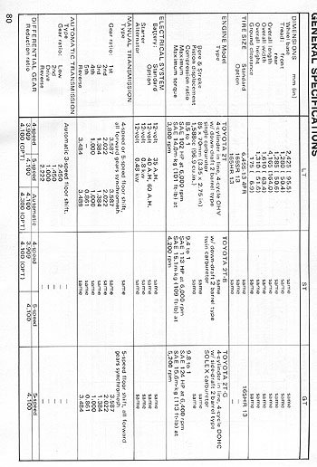
185/70 13” = 589mm
195/70 13” = 603mm
205/65 13” = 597mm
215/60 13” = 588mm
215/65 13” = 610mm
225/60 13” = 600mm
235/6013” = 612mm

14”

195/60 14” = 590mm
215/60 14” = 614mm
245/50 14” = 601mm

15”

195/55 15” = 596mm
205/50 15” = 586mm
205/55 15” = 607mm
215/50 15” = 596mm
225/50 15” = 606mm
235/45 15” = 592mm
235/50 15’ = 616mm
245/45 15” = 601mm

16”

195/50 16” = 601 mm
205/45 16’ = 591 mm
205/50 16” = 611 mm
215/45 16” = 600 mm
225/45 16” = 609 mm
235/40 16” = 594 mm

